Student name________
Title
To come up with a small glass ampoule filled with hydraulic oil in ac power plugs, sockets and surge protector in order to reduce the accidents of fire.
Introduction
For a long period of time fuses have been used as circuit breakers whenever power is high in order to protect devices in homes and many other places where electricity is used however, they are been unreliable due to the following reasons; their protection is unreliable, they have a low breaking capacity and at the same way they are slow as compared to other circuit breakers (fuse, 2021). This necessitated invention of a glass ampoule filled with hydraulic oil in this case I used mercury this is because it’s a good conductor of electricity and its not combustible therefore can’t cause fire accidents.
Procedure
I used a socket and a plug in this case and replaced the fuse with the glass ampoule filled with mercury. The diagrams below illustrate the socket and the plug.
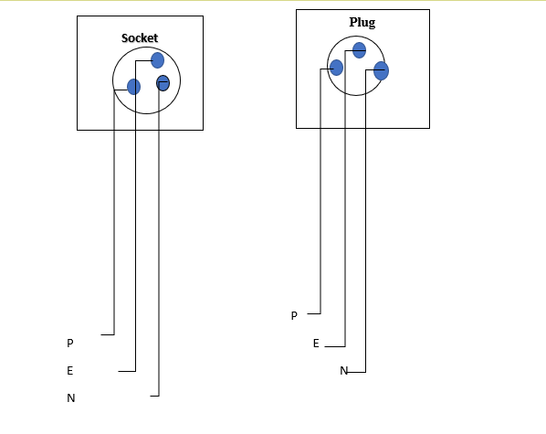
Hard glass has a linear expansivity of 5.9 um/m/0c ("Coefficients of Linear Thermal Expansion", 2021) therefore when electricity with high power passes through the ampoule it heats the mercury inside the glass ampoule which in turn heats the glass and upon reaching at its linear expansivity it breaks spilling the mercury therefore breaking the circuit and preventing more current flow. Mercury is preferred in this case because of its high melting point. The boiling point of mercury is 356.70c a very high melting point("mercury | Definition, Uses, Density, & Facts", 2021) that won’t be reached before reaching at the temperature at which glass breaks.
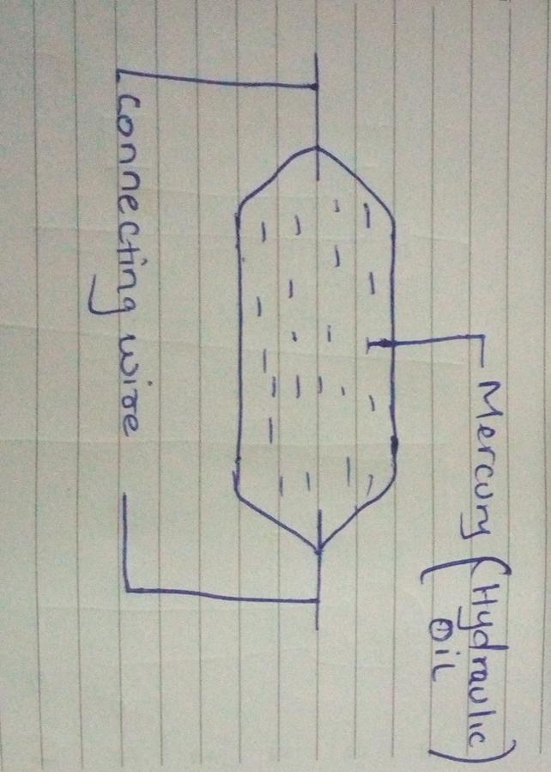
The above diagram is of a glass ampoule filled with mercury as the hydraulic oil.

Conclusion
Glass ampoules filled with mercury should be highly adopted as circuit breakers since its simple to construct and less hazardous and therefore reducing the risk of fire.

References
Fuse, A. (2021). ECSTUFF4U for Electronics Engineer. Ecstuff4u.com. Retrieved 2 July
2021, from https://www.ecstuff4u.com/2020/01/advantage-disadvantage-fuse.html.
Coefficients of Linear Thermal Expansion. Engineeringtoolbox.com. (2021). Retrieved 2 July 2021, from https://www.engineeringtoolbox.com/linear-expansion-coefficients-d_95.html.
Mercury | Definition, Uses, Density, & Facts. Encyclopedia Britannica. (2021). Retrieved 2
July 2021, from https://www.britannica.com/science/mercury-chemical-element.

